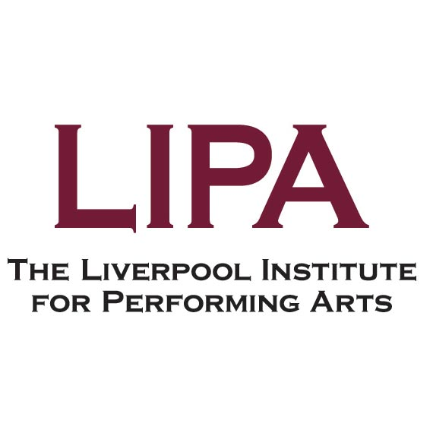

Job Description

Job Title | Lecturer in Music (Popular Music Studies)
Salary Scale | Lecturer (SCP 30 – SCP 36)
Responsible To | Head of Music (Academic)
Responsible For | Not applicable
Number in Post | 5
Date Drafted | July 2026

Job Purpose
To contribute, as required by the Head of Music (Academic), to services provided by the Department to which the post holder is appointed.

Major Tasks
- Teaches Music and related subjects to students enrolled on a range of courses as assigned by the Head of Discipline, depending on knowledge and experience.
- Manages modules or parts of courses as required.
- Assesses students by the formal or informal methods required by external examining bodies and internal procedures.
- Contributes to curriculum innovation, development and implementation.
- Assists in the implementation of pastoral and welfare systems provided for students.
- Continues personal and professional development in the areas of both subject knowledge and teaching methods.

Job Activities
Major Task 1: Teaching
- Teaches a range of students and groups including tutorial work as well as classroom teaching.
- Undertakes organisational and administrative duties associated with the teaching responsibilities of the post.
- Supervises practical activities and workshops as appropriate.
- Facilitates learning by selection of material and methods appropriate to student needs and course level.
- Provides students with feedback and guidance to support their learning and enhance their knowledge of progress within the constraints of assessment confidentiality.
- Works effectively with other teaching, administrative and managerial staff in ensuring a high quality of learning experience for our students.
Major Task 2: Management of Modules
- Promotes equality of opportunity for all students on programmes of study within the department/Institute.
- Plays an active role in the marketing of the subject area/LIPA that may involve liaison with external agencies or other educational providers and attendance at open days/evenings or publicity events.
- Leads other staff assigned to teaching duties on modules for which the post holder has been assigned module leadership.
- Maintains accurate and up to date records (registers, timetables etc.) as required by the Head of Discipline.
- Prepares written reports for the Head of Discipline, relevant funding bodies and other agencies when required.
- Plans effective learning activities, recruits visiting lecturers and manages assessment tasks appropriately.
Major Task 3: Assessment
- To prepare assignments and assignment materials as required.
- To take part in assessment tasks including providing marks, giving written and verbal feedback as required, and participating in moderation processes.
- To attend Board of Examiner meetings as required.
Major Task 4: Curriculum Innovation
- To participate in curriculum reviews, innovation and change in response to Institute or external needs or demands.
- To contribute to curriculum development.
- To implement curriculum change resulting from innovation and development.
- To liaise with external organisations associated with education and training in the Performing Arts.
- To develop course materials.
Major Task 5: Pastoral and Welfare
- Acts as Personal Tutor for a group of students, undertaking student welfare, academic and non-academic support as appropriate.
- Prepares and submits reports of students to internal and external authorities about their progress, attainment, personal qualities, interests, potential, discipline, etc.
- Identifies students in need of support and refers students as appropriate to partner agencies or LIPA internal student support team.
- Prepares references for students seeking employment and making subsequent educational applications.
Major Task 6: Other Duties
- Work flexibly including contributing to work projects of a general nature and providing cover for other staff.
- Participate in staff appraisals and training programmes as required
- Carry out duties at all times with due regard to Data Protection/confidentiality, Equal Opportunities, Health and Safety and other policies as agreed and revised from time to time

Notes:
The duties and responsibilities attached to posts may vary from time to time without changing the general character of the duties or the level of responsibility entailed. Changes outside of this description will only be made after consultation with the aim of reaching agreement with the person concerned and will be recorded on the individual's job description.
Location:
Whilst the job is located on our main site, the post holder may occasionally be required to work on different duties or other jobs within their competence in their present or any other location as may be deemed appropriate. In all cases, regard will be paid to the qualifications, experience, current duties and responsibilities, and personal circumstances of the post holder.
The post may involve some travel overseas.
Hours:
Lecturers are expected to work such hours as are reasonably necessary for the proper performance of their duties. Contractually, formal scheduled teaching hours will not normally exceed 510 over the course of the academic year, excluding assessment, induction, and tutorials.

Person Specification – Lecturer in Music (Popular Music Studies)

 |  | To be identified by:
Education and Qualifications:
A good Bachelor level degree in Music or other relevant subject | Essential | Application Form /Certificates
Music-related Master's level degree | Essential | Application Form /Certificates
PhD in Music, or nearing completion | Essential | Application Form /Certificates
A recognised HE teaching qualification or fellowship of the HEA | Desirable | Application Form /Certificates
Experience / Knowledge:
High level of knowledge and understanding of the academic field of popular music studies | Essential | Application Form/ Interview
Understanding of contemporary, popular and commercial music | Essential | Application Form/ Interview
Experience of researching in the field of popular music studies | Essential | Application Form/ Interview
Experience of teaching popular music studies in a HE setting | Desirable | Application Form/ Interview
Skills and Ability:
Strong written/verbal communication skills | Essential | Interview
Demonstrable interpersonal skills of a high order and ability to work as a member of a team | Essential | Interview
Commitment:
To LIPA’s Equality, Diversity and Inclusion policies and practice. | Essential | Interview
To the provision of a high level of service to students and staff. | Essential | Interview
To work with enthusiasm and flexibility. | Essential | Interview

