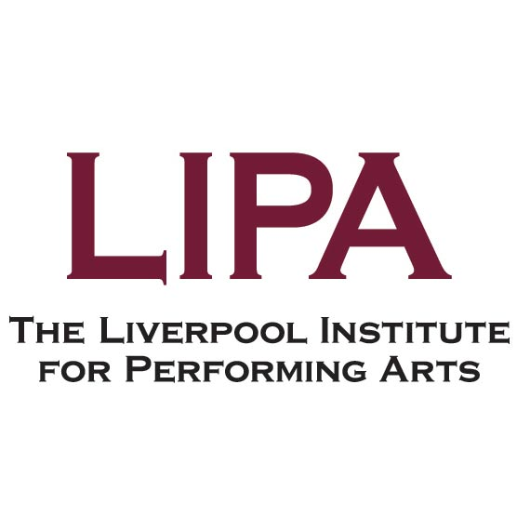

Job Description

Job Title | Technician (Live Sound)
Salary Scale | LIPA Scale 5
Responsible To | Technical Services Manager
Responsible For | N/A
Number in Post | 1
Date Drafted | August 2026

Job Purpose
Responsible for the supervision, maintenance and booking of live sound equipment in support of curriculum delivery and internal / external performances / events.
To co-ordinate with the live sound lectures, show co-ordinator and the productions technical team and to assist the Technical Services Manager in supporting curriculum delivery across the Institute along with providing a customer facing role for bookings and events.

Major Tasks
- Ensure adequate arrangements exist for the storage, distribution, and maintenance of Live Sound equipment.
- Provide first-line technical support and ensure the smooth processing of equipment booking requests generated from Smarthub, the Institute’s booking system.
- Maintain a safe and secure environment within the areas for which the technician is responsible.
- Co-ordinate with the Productions Technical department to assist and ensure the running of LIPA productions and events.
- Support the Sound Technology / Theatre Performance Technology departments, providing equipment and technical support for live sound lectures / seminars.
- Assist with budget preparations and the ordering of equipment.
- Undertake duties common to all technical staff of the Institute, including streaming services and distribution of technical equipment in the technical services counter.

Job Activities
Major Task 1: Storage, Distribution and Maintenance of Equipment
  - Ensure equipment and materials are stored in a safe, secure and tidy manner.
  - Ensure equipment and materials are itemised and recorded in accordance with Institute’s stock control procedures.
  - Be responsible for the maintenance of a schedule of planned activities to ensure equipment is available to meet the demands of the curriculum, utilising Siso Smarthub, the Institutional resource management system.
  - Be responsible for the co-ordination and allocation of live sound equipment to teaching areas in accordance with staff requests.
  - Facilitate equipment issues and returns in accordance with the Institute’s policy and Financial Regulations.
  - Undertake first line maintenance, repair and fault finding of live sound equipment.
  - Ensures students know how to use the booking system to book equipment for shows/events.
  - Ensure live sound equipment and installations are serviced and maintained in accordance with manufacturer recommendations, and therefore available for use on a daily basis.
Major Task 2: Provide first-line technical support and ensure the smooth processing of equipment booking requests
- Provide ad-hoc demonstrations of live sound equipment and software to students, working in conjunction with teaching staff delivering live sound modules.
- Provide support for productions systems including (but not limited to), Radio Mics and IEM systems, audio consoles; Digico, Allen & Heath, Yamaha and Soundcraft. Speaker and amplifier systems from d&b and Audiotechnik.
- Provide support for live sound events taking place across the institute which incorporate fibre optic and audio network systems such as Dante, Sisco Switches etc and audio management systems.
- Provide support for Comms Systems such as Clear-Com (alongside Productions team).
- Ensure the timely processing of ad-hoc booking requests generated by staff and students to enable them to make equipment bookings across the Institute.
- Staff the Technical Services counter on a rota basis with other members of the Technical Services team.
- Provide bespoke technical equipment support to staff and students.
- Liaise with students and staff regarding the use of live sound facilities, including integration within the curriculum, timetable, other courses’ needs.
- Plan time within facilities to allow for the load-in and load-out of live sound equipment.
- Attend production meetings to manage show expectations and ensure adequate distribution of equipment across the institute.
- Assist live sound teaching staff with the planning of off campus productions and outside events.
- Assist with official LIPA live events, such as open days, masterclasses, etc.
Major Task 3: Maintaining a Safe and Secure Environment
  - Ensure that the Institute’s Health and Safety policy / procedures are implemented within areas of responsibility.
  - Ensure work areas are always kept in a clean and tidy manner.
  - Maintain adequate levels of security for Institute property.
  - Assist live sound teaching staff with the assessment of risk on and off campus productions.
  - Supervise students when working at height or rigging equipment in coordination with the technical productions staff.
Major Task 4: Assist and ensure the running of LIPA productions and events
- Co-ordinate with the Productions technical department to assist and ensure the running of LIPA productions and events.
- Facilitate technical sound requirements for open days and other LIPA events.
Major Task 5: Support the Sound Technology / Theatre Performance Technology departments, providing equipment and technical support for live sound lectures / seminars
  - Provide bespoke advice and assistance for students and staff relevant to the subject.
  - Have knowledge of the relevant subject / module areas to provide and advise on suitable solutions for productions on and off campus.
  - Carry out technical demonstrations under the guidance of teaching staff.
  - Prepare technical facilities for teaching staff as required.
  - Ensure the LIPA Technical Services Hub site is kept up to date and relevant, working with other members of the team to upload and maintain content.
  - Assist live sound teaching staff with co-ordination and support of productions both on and off campus, including communications with the local authority where needed.
Major Task 6: Assist with budget preparations and the ordering of equipment
  - Assist with ordering materials and equipment as directed.
  - Assist in the preparation of annual estimates and budgets for equipment.
  - Assist with the delivery of equipment and the reconciliation of deliveries to goods received notes.
  - Assist the Technical Services Manager, Sound Technology staff, Theatre Performance Technology staff and Productions departments to prepare bids for equipment.
  - Assist the Technical Services Manager regarding the ongoing costs of productions both on and off campus.
Major Task 7: Undertake duties common to all LIPA Technical staff
  - Work flexibly, contributing to the Institute’s projects of a general nature and, under supervision, providing cover and support for other technical staff as appropriate.
  - Ensure appropriate financial / stock records are maintained and updated in accordance with the Institute’s Financial Regulations.
  - To participate in staff appraisals and training programmes as required.
  - To carry out duties at all times with due regard to Equality and Diversity, Health and Safety and other Institute policies as agreed and revised from time to time.

Notes:
The duties and responsibilities attached to posts may vary from time to time without changing the general character of the duties or the level of responsibility entailed. Changes outside of this description will only be made after consultation with the aim of reaching agreement with the person concerned and will be recorded on the individual's job description.
Location:
Whilst the job is located on our main site, the post holder may occasionally be required to work on different duties or other jobs within their competence in their present or any other location as may be deemed appropriate. In all cases, regard will be paid to the qualifications, experience, current duties and responsibilities, and personal circumstances of the post holder.
Hours:
Usually 37.5 hrs per week, Monday – Friday, although there may be situations whereby the postholder will need to put in the hours to ensure that e.g., agreed project deadlines are met.

Person Specification – Technician (Live Sound)
 |  | To be identified by:
Education and Qualifications:
A degree or equivalent qualification in a relevant subject. | Essential | Application Form
Experience:
Experience in booking equipment and maintaining robust booking systems. | Essential | Application Form
Experience in a similar role in an HE or FE environment. | Essential | Application Form
Experience in the operation of digital and analogue audio systems. | Essential | Application Form
Experience of configuring and deploying digital audio networks and radio mic systems. | Essential | Application Form / Interview
Experience of working in a theatre and events environment. | Desirable | Application Form / Interview
Experience of first line equipment maintenance, including PAT testing. | Essential | Application Form / Interview
Experience of working for multiple stakeholders in a customer facing environment. | Essential | Application Form
Skills and Knowledge:
Thorough working knowledge of analogue and digital audio systems and equipment. | Essential | Application Form / Interview

Thorough working knowledge of digital audio networking, including network switches, and PA control systems such as Arraycalc and d&b’s R1 software. | Essential | Application Form / Interview
Thorough working knowledge of radio microphone systems and software. | Essential | Application Form / Interview
Knowledge of audio editing / playout software such as Pro tools, Logic, QLab. | Desirable | Application Form / Interview
Thorough knowledge of at least one industry standard Comms system such as ClearCom etc. | Desirable | Application Form / Interview
Knowledge of Microsoft SharePoint. | Desirable | Application Form / Interview
Knowledge of Apple Macintosh systems, hardware and software. | Essential | Application Form / Interview
Knowledge of MS Office Applications, including (but not limited to) Word, Excel, PowerPoint. | Essential | Application Form / Interview
Knowledge of equality and diversity issues in relation to teaching, learning and assessment in Higher Education. | Desirable | Application Form / Interview
Excellent oral and written communication skills. | Essential | Interview
Organised and methodical. | Essential | Application Form /Interview
Ability to work on own initiative and independently. | Essential | Application Form / Interview
Excellent attention to detail. | Essential | Application Form
Ability to identify areas for improvement and identify possible solutions. | Essential | Interview
Ability to assimilate detailed information and identify key issues. | Essential | Interview
Willingness to learn and adapt to different situations. | Essential | Interview
Commitment:
Contribute to advancing professional practice through an inclusive and equitable approach. | Essential | Application Form / Interview
Willingness to work flexibly, to travel when necessary and undertake appropriate training. | Essential | Application Form / Interview
Strong commitment to the development of artistic practice. | Essential | Application Form / Interview
To LIPA’s Equality, Diversity and Inclusion policies and practice. | Essential | Interview
To the provision of a high level of service to students and staff. | Essential | Interview

